Parents’ Evening - How to Book Your Appointment
- Choose the appropriate link depending on the campus your son or daughter studies at.
- From the list select the relevant curriculum area, in this example, Business
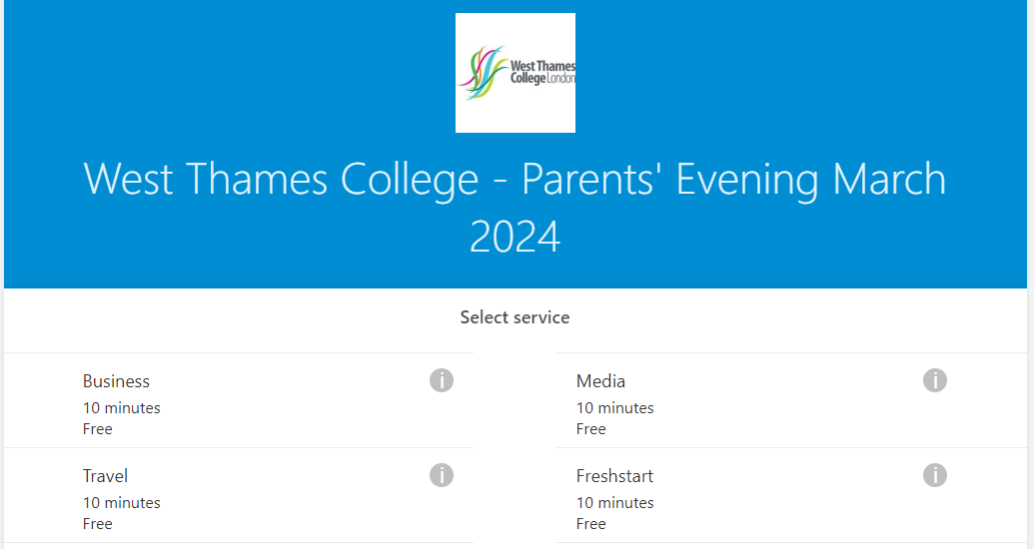

- Scroll down to select the date – 4 March Isleworth Campus, 7 March Feltham Campus
- Select the member of staff you wish to meet with from the drop down list. Please do not select “Anyone” it is important that you meet with your son or daughter’s teacher. If you are not sure who their teachers are, please check their timetable.
- Select the most suitable 10 minute slot
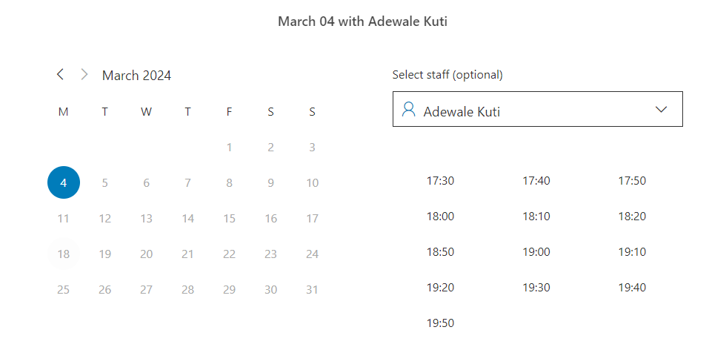

- Scroll down to add your details: Your name, email address, your mobile number, your son or daughter’s name and their Student ID number (this can be found on the invitation email you received)
- Click Book to confirm
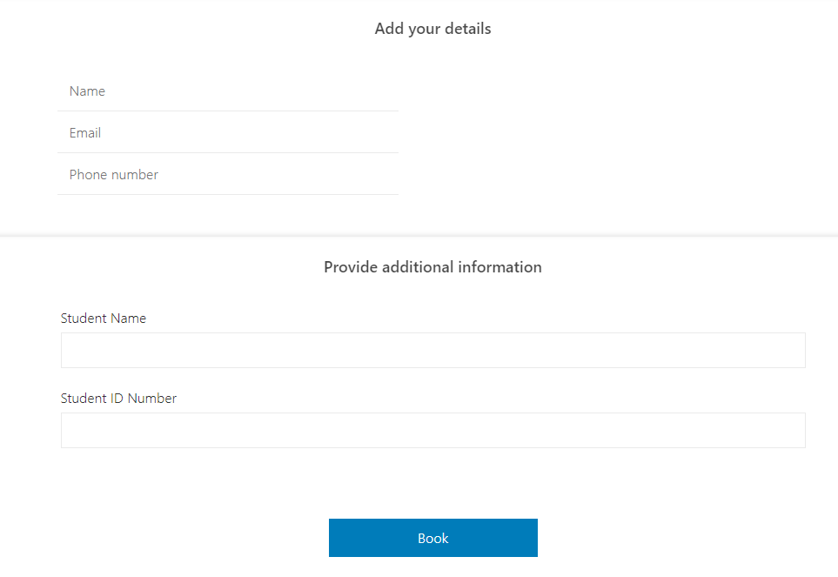

- You will receive a confirmation message and email
- If you need to make another appointment with a different teacher, including English or maths, please start this process again by clicking “New Booking”. Please remember to allow enough time to move between locations; we recommend 10 minutes between bookings.
- If you have multiple young people please make a booking for each student.
